# NVRAM CLEAR PROCESS

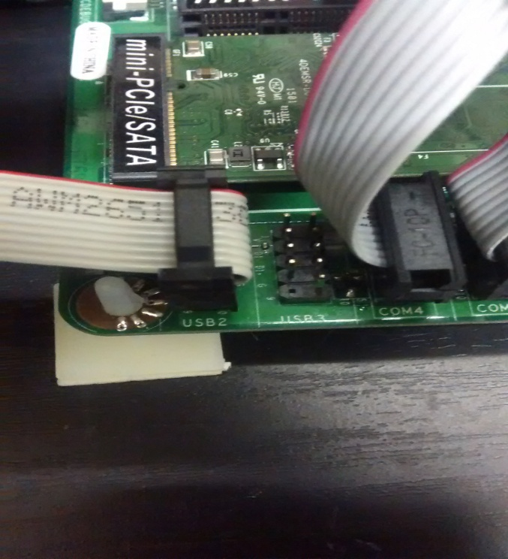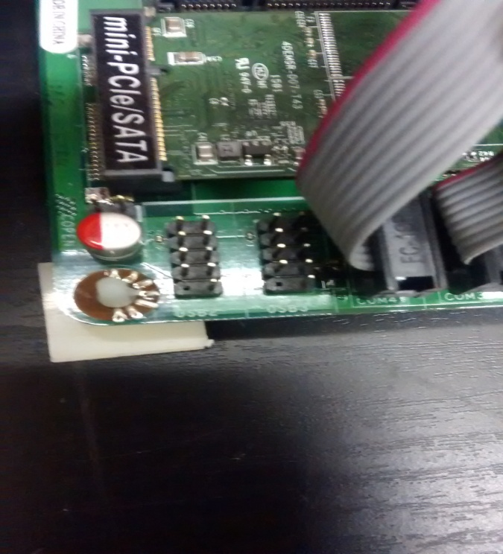

**2**

**1**

**1**

|  |  |
| --- | --- |
| CONNECTING RAM CLEAR CABLE TO BOARD | |
| **1** | **Step 1:** Locate the USB ports on the bottom left corner of the JETWAY PCB. the port will be labeled USB 1 and next to it will be labeled USB 2. |
| **2** | **Step 2:** Plug the other end of the ram clear cable into either USB 1 or USB 2 (both will work the same). be sure that the red colored wire on the ribbon cable is on the top of the cable (facing the inside of the PCB, same as the BV and PRNTER as seen in picture above) |

# NVRAM CLEAR PROCESS

NVRAM CLEAR PROCESS – STEPS

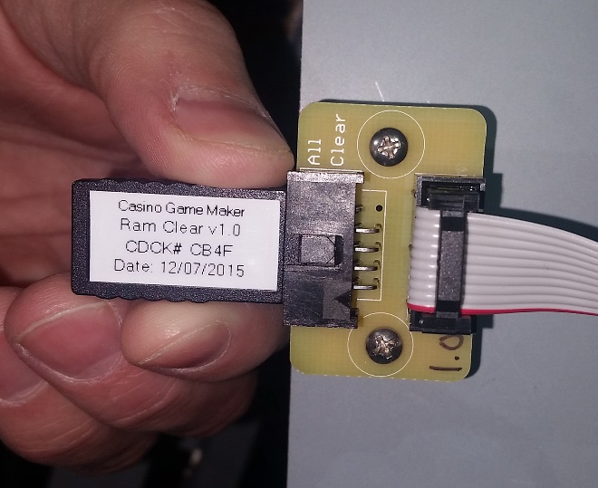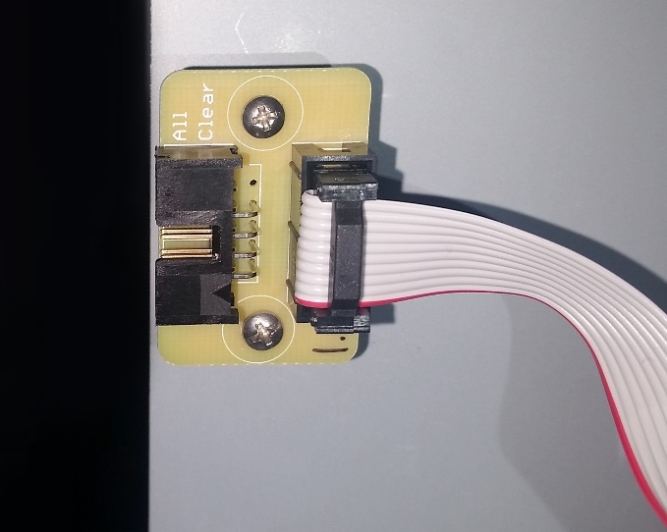

**2**

**1**

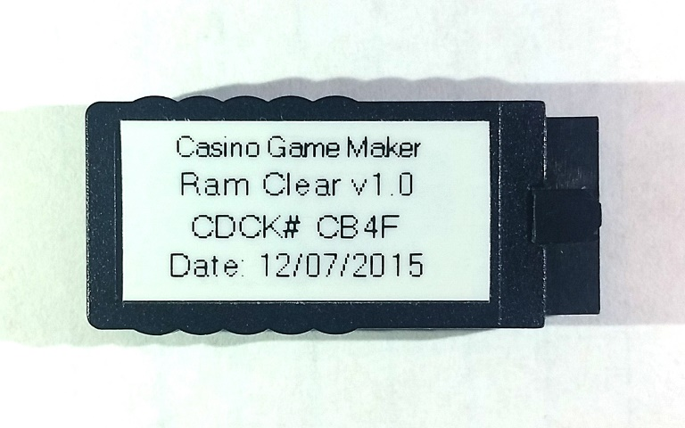

**3**

|  |  |
| --- | --- |
| NVRAM CLEAR PROCESS | |
| **1** | **STEP 1:** Turn all power off from the EGM. Open logic box and locate the NVRAM clear slot mounted on the inside of the Logic Box. |
| **2** | **STEP 2:** Insert the USB NVRAM clear device into the NVRAM clear slot. Verify device’s tab aligns with the notched out section of the housing. |
| **3** | **STEP 3:** Apply power to EGM and wait for boot up. A message will soon appear on the user interface screen informing you that NVRAM has been cleared.  Turn all power off from EGM. Unplug NVRAM clear device and re-apply power to EGM |